HELLO 2K18

I wish to try a big parc aquatique with my family and a verry big parc of attractions with my friends.

If I were rich, I'd buy a villa with a verry verry big swimming pool and a huge wild river, with soccer field, basketball court ands sports Hall.

I wish I could spend time with my family, my friends and my cat this summer.
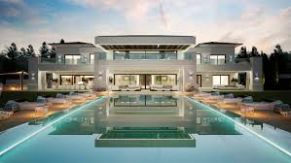

Places, I'm willing to discover are Tahiti, Bahamas...

If I could, I'd change these habits :
-Stop dramatizing.
- Stop getting upset too quickly.

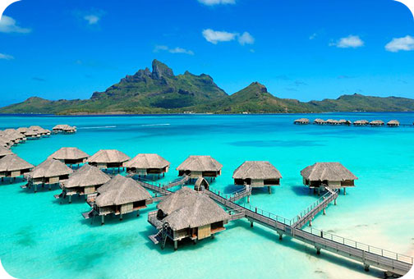

Leclerc Flavie 4°D

