Hello 2018

Activities: I wish to try sky, nba game
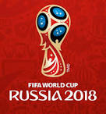
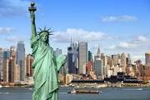
Places: I'm willing to discover USA,Football World Cup in Russia

If I could, I'd change these habits: -to be less grumpy
-a little less typing my brother and
my sister
If I were rich, I'd buy :- a villa
- the nba club of San Antonio
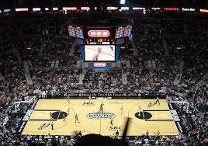

I wish I could spend time withmy family and my friends

