Activities I wish to try :
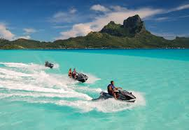
Jet Ski ,watch match football in Saint étienne , watch concert Niska
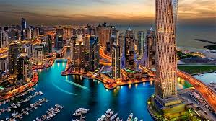
Places I'm willing to discover :
united State, Iland, Dubai , Paris
If I could, I'd change these habits :
go to bed earlig
If I were rich, I'd buy :
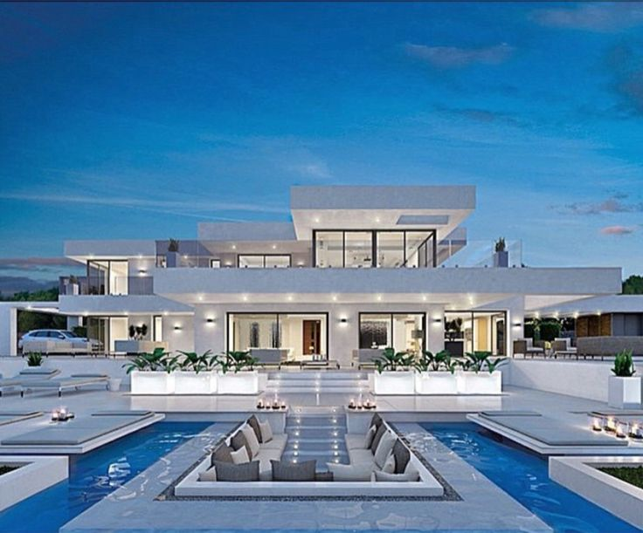
Villa, Iphone, Make to my family and my friend happy
I wish I could spend time with :
My friends, my family

