♣ My plans to 2018 ♣

• I'd like to try Virtual Reality Headsets and Graphic Tablets.

• I'd like to visit London, Tokyo, Los Angeles, The Wales and Australia.
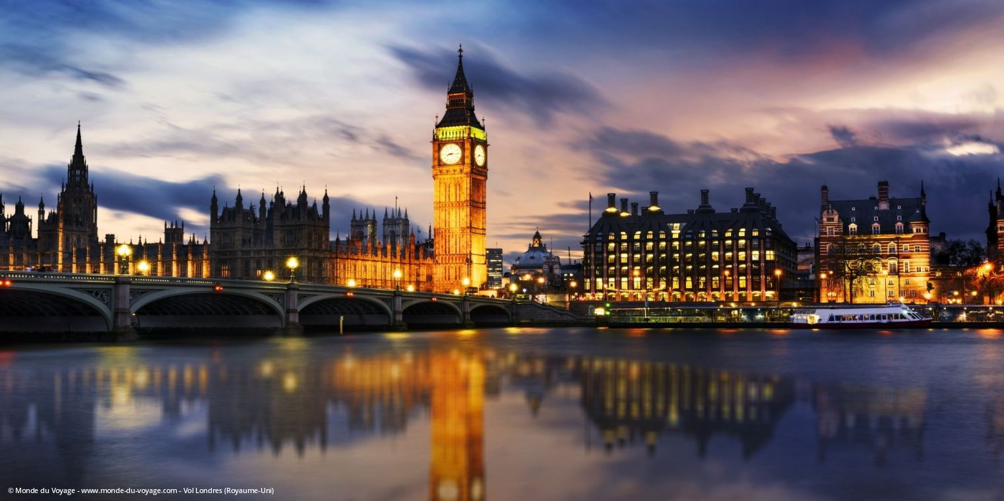
• I wish I could spend time with four of my friends, Lucie, Ozanne, Marine and Circée.

• If I were rich, I'd buy a Graphic Tablet (Wacom Cintiq 24HD), many CD's, books, video games and movies. I'd go to concerts. I'd buy a RoG (Republic Of Gamers).
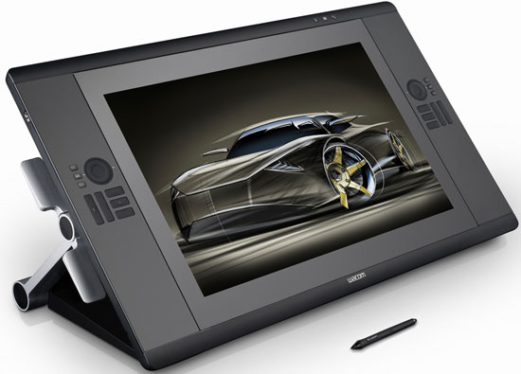
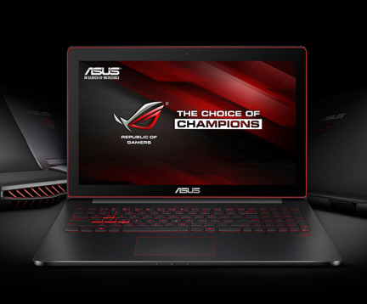
• If I could, I'd talk less in class and I'd stop being on my cellphone all evening.

