Hello 2K18

- Activities I wish to try swim with dauphins and take a ride in a helicopter.

- Places I'm willing to discover a Dineyland Paris, New York and paradise islands.

- If I could, I'd change these habits participate more in class and not be late in the morning.

- If I were rich, I'd buy a villa with infinity pool, a makeup and things for my family.

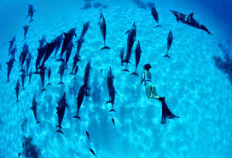

- I wish I could spend time with my family and my friends.

