Hello 2K18 !

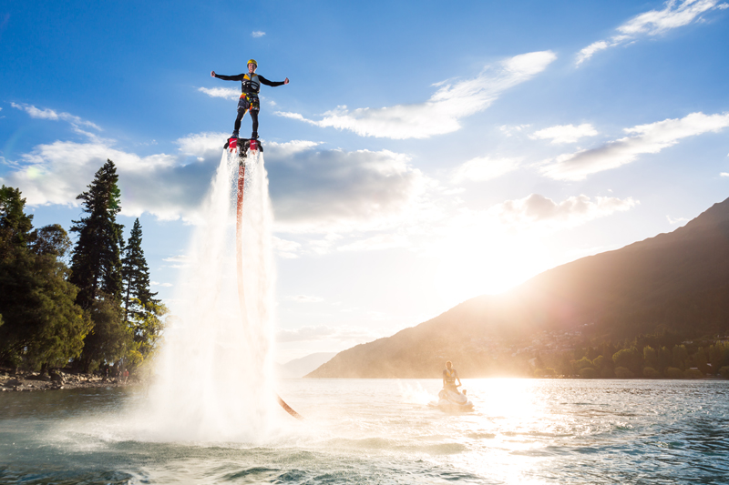
My plans for 2018 , I would like to try a flyboard and I go to the Park Astérix.

I would try to go bed earlier. I would like to go to Tahiti and New York.
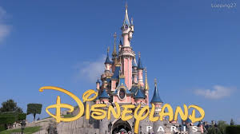
I wish I could spend time with my friends in DisneyLand Paris.

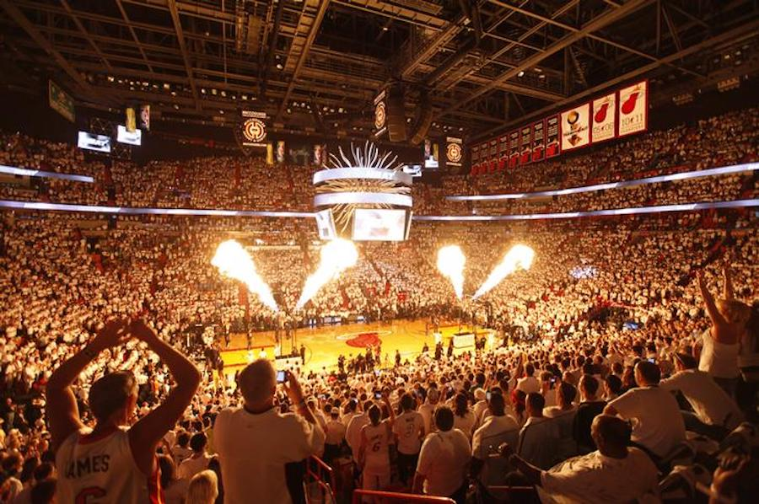
If I were rich, I'd buy lot of makeups, places for match NBA and I'd buy a big villa.

