Hello 2018

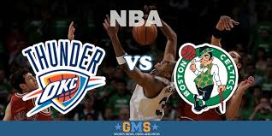
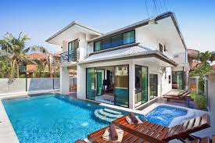
Activities I wish to try skii, NBA Game (Boston-Oklahoma city). Places I'm willing to discover New-York, London and football word cup. If I could, I'd change these habits never feel tired again. If were rich, I'd buy a villa, an NBA basketball club (BOSTON) and I wish I could spend time with my family and my friends.

