Lettres de femmes, Augusto Zanovello
Etude de la composition de la bande-annonce
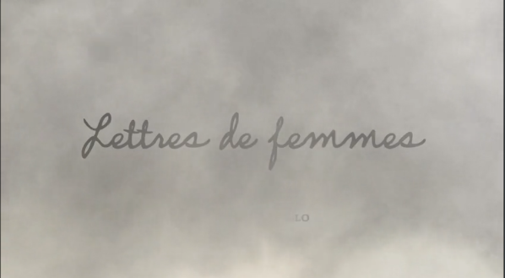
1. …………………………………………………………………………………………………………
………………………………………………………………………………………………………………
………………………………………………………………………………………………………………
………………………………………………………………………………………………………………
2. …………………………………………………………………………………………………………
………………………………………………………………………………………………………………
………………………………………………………………………………………………………………
………………………………………………………………………………………………………………
3. …………………………………………………………………………………………………………
………………………………………………………………………………………………………………
………………………………………………………………………………………………………………
………………………………………………………………………………………………………………

4. …………………………………………………………………………………………………………
………………………………………………………………………………………………………………
………………………………………………………………………………………………………………
………………………………………………………………………………………………………………
5. …………………………………………………………………………………………………………
………………………………………………………………………………………………………………
………………………………………………………………………………………………………………
………………………………………………………………………………………………………………

6. …………………………………………………………………………………………………………
………………………………………………………………………………………………………………
………………………………………………………………………………………………………………
………………………………………………………………………………………………………………

7. …………………………………………………………………………………………………………
………………………………………………………………………………………………………………
………………………………………………………………………………………………………………
………………………………………………………………………………………………………………
8. …………………………………………………………………………………………………………
………………………………………………………………………………………………………………
………………………………………………………………………………………………………………
………………………………………………………………………………………………………………
9. …………………………………………………………………………………………………………
………………………………………………………………………………………………………………
………………………………………………………………………………………………………………
………………………………………………………………………………………………………………
10. …………………………………………………………………………………………………………
………………………………………………………………………………………………………………
………………………………………………………………………………………………………………
………………………………………………………………………………………………………………
11. …………………………………………………………………………………………………………
………………………………………………………………………………………………………………
………………………………………………………………………………………………………………
………………………………………………………………………………………………………………

12. …………………………………………………………………………………………………………
………………………………………………………………………………………………………………
………………………………………………………………………………………………………………
………………………………………………………………………………………………………………

c) La lumière et les couleurs
……………………………………………………………………………………………………………………………………………………………………………………………………………………………………………………………………………………………………………………………………………………………………………………………………………………………………………………………………………………………………………………………………………………………………………………………………………………………………………………………………………………………………………………………………………………

