**………………………..’S COMING FOR US, SIA**

Nights are getting shorter now, hot chocolate



fills the air and ………………………………..  cheer does too  
Picking out your Christmas ………………………………, so lovely  
The …………………………. this time it brings to you  
  
……………………..'s coming to town  
……………………..'s coming to town  
  
Sing it to the ………………………..  in the ………………………….   
Sing it as they jingle, jingle, jingle ……………………………  
Sing it to the ………………….., set it ……………………………..  
You're the angel on the top of my …………………………….  
Sing it to the spirit above  
Sing your heart out with all of your ………………………….  
……………………….'s coming for us  
……………………….'s coming for us (x6)

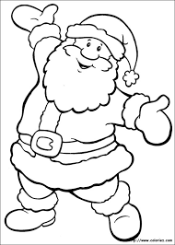

Send your letters off to ……………………….., baby  
Tell him all your ………………………… wishes too  
Send your letters off to …………………………., baby  
Hoping all your wildest ………………………….come true  
  
…………………………..'s coming to town  
…………………………..'s coming to town  
  
Sing it to the …………………… in the …………………….   
Sing it as they jingle, jingle, jingle ………………………  
Sing it to the ………………………, set it ……………………  
You're the angel on the top of my ………………………  
Sing it to the spirit above  
Sing your heart out with all of your ……………………  
………………………….'s coming for us  
………………………….'s coming for us (x6)