Hello 2018 !

Activities : I wish to try water park, Futuroscope .
Places : I'm willing to discover New York, NBA game,Dubai
If I could, I'd change these habits never feel tired again .
If I were rich , I'd buy an nba basketball club , a villa.
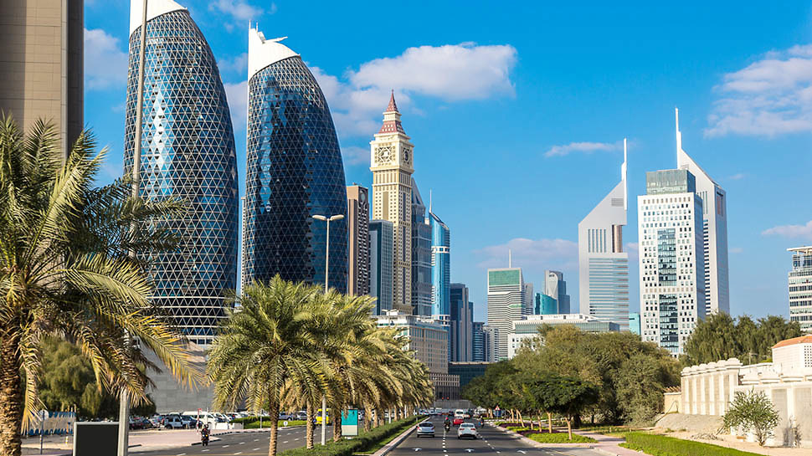
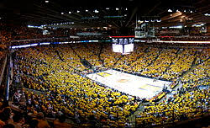
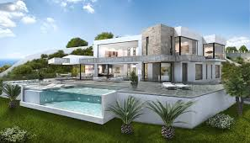
I wish Icould spend time with my family , my friends and neymar.

